**PCET’s DISTINGUISHED ALUMNI**

**Argha Chatoppadhyay** 

**Sound Cloud**

**Berlin, Germany**

**Salary: 72 Lacs**

**Graduated in 2011**



**Swijal Patil**

**Amazon, USA**

**Salary: 60 Lacs**

**Graduated in 2012**

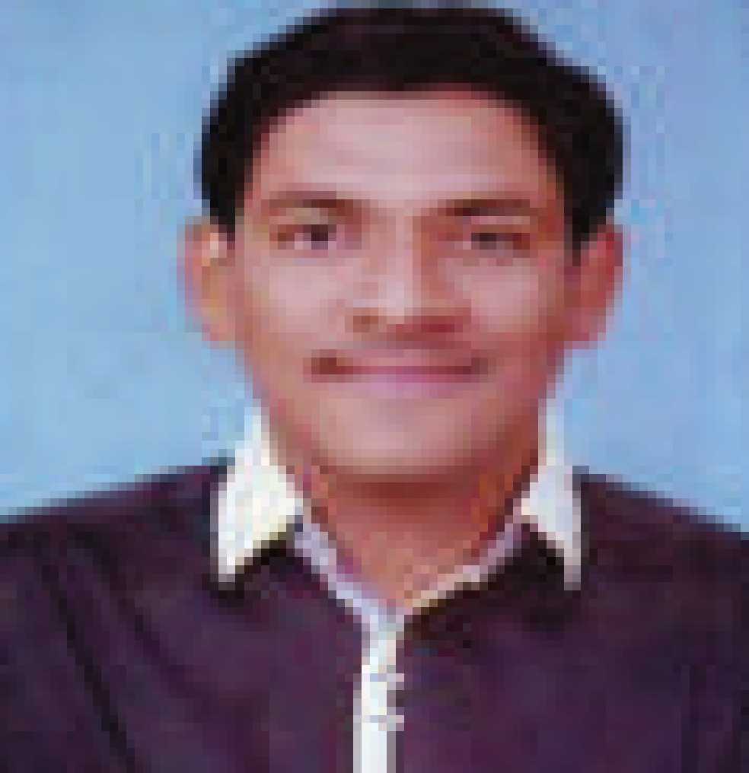

**Harshal Borse**

**Entrepreneur**

**Green Globe Biotechnologies**

**Turnover: 2 Crore**

**Shivanshi Shukla** 

**M.S at Michigan Tech University,**

**USA**